

Numiqer’s Bootcamp Project

Limelight 2024

Submitted To:

Abhishek Pandey

**Data Science**

Submitted By:

Surya Pratap Singh

***Claim Prediction Model***

**Task 1:** Conduct exploratory data analysis on historical claims data.

**Deliverable 1:** An Exploratory Data Analysis (EDA) report detailing findings.

*Research and Approach Planning*

Exploratory Data Analysis (EDA) is an essential first step in any data analysis project. It serves as the foundation for understanding the structure, characteristics, and patterns within a dataset. Through a combination of statistical summaries, data visualization techniques, and data cleaning, EDA allows us to:

* **Gain Insights:** Uncover underlying trends, relationships, and anomalies within the data.
* **Identify Patterns:** Recognize recurring themes or behaviors that can inform further analysis.
* **Detect Outliers:** Pinpoint data points that deviate significantly from the overall trend, potentially indicating errors or unique cases.
* **Formulate Hypotheses:** Develop initial conjectures about the data based on the observed characteristics.

**Benefits of EDA**

By performing a thorough EDA, we equip ourselves to make informed decisions throughout the data analysis process. This includes:

* **Selecting Appropriate Models:** Choosing the most suitable statistical or machine learning models based on the data's properties.
* **Preparing Data for Modelling:** Cleaning and transforming the data to ensure its compatibility with the chosen models.
* **Improving Decision Making:** Leveraging the insights gained from EDA to make data-driven decisions that are grounded in a comprehensive understanding of the data.

**Overall, EDA serves as a bridge between raw data and meaningful analysis, paving the way for robust and reliable conclusions.**

*Demonstration*

**Data Exploration: Historic Claims Analysis**

This section details the exploratory data analysis (EDA) conducted on historical claims data. The data has been divided into training and testing sets, each containing three primary components:

1. **Beneficiary Data:** This section houses information pertaining to the chronic conditions diagnosed for each beneficiary.
2. **Inpatient Data:** This component encompasses data associated with beneficiaries who were hospitalized. It provides detailed records of their inpatient stays.
3. **Outpatient Data:** This category focuses on beneficiaries who did not require hospitalization. It includes information gleaned from their outpatient medical records.

By performing a comprehensive EDA on these datasets, we aim to gain a deeper understanding of the characteristics and relationships present within the historical claims data. This understanding will prove invaluable in subsequent stages of the analysis.

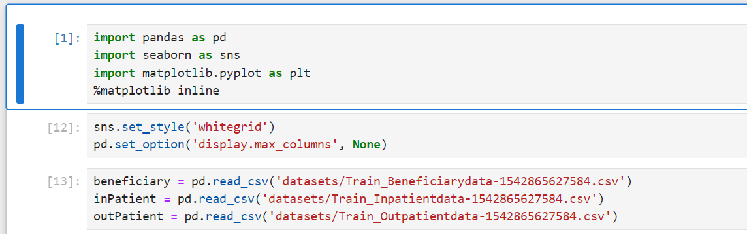

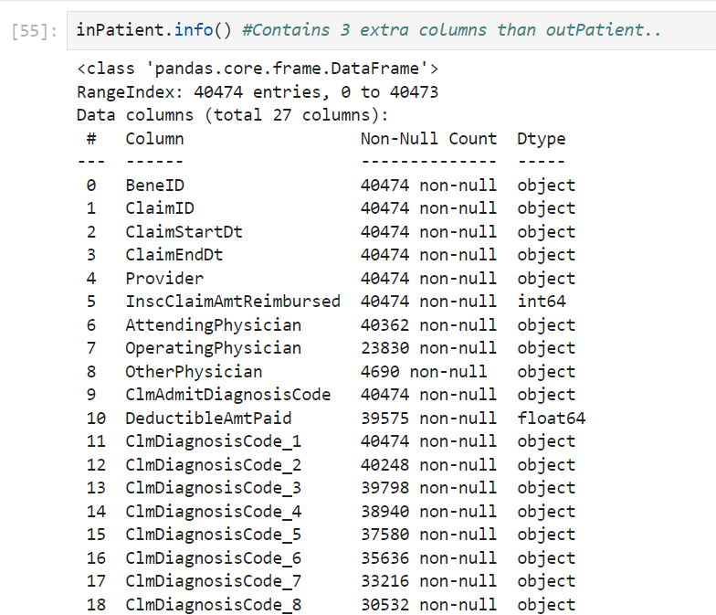

**Figure 1:** Displaying extra columns in InPatient data



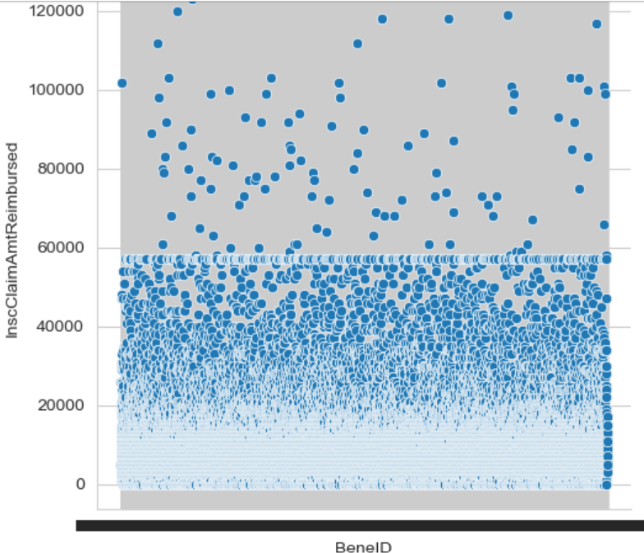

**Figure 2:** Claim amount joint-plot with Beneficiary Id

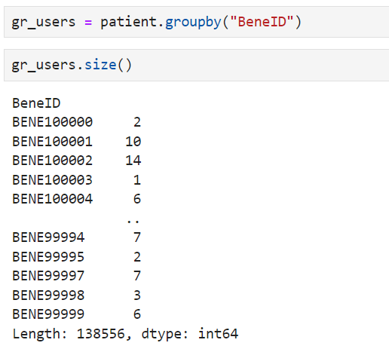

**Figure 3:** EDA Analysis (Number of claims by a single beneficiary)

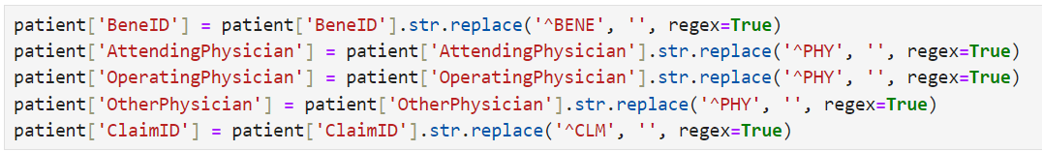

**Figure 4:** Data cleaning for further processing

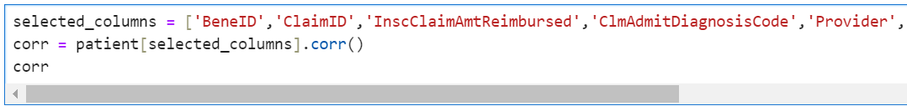

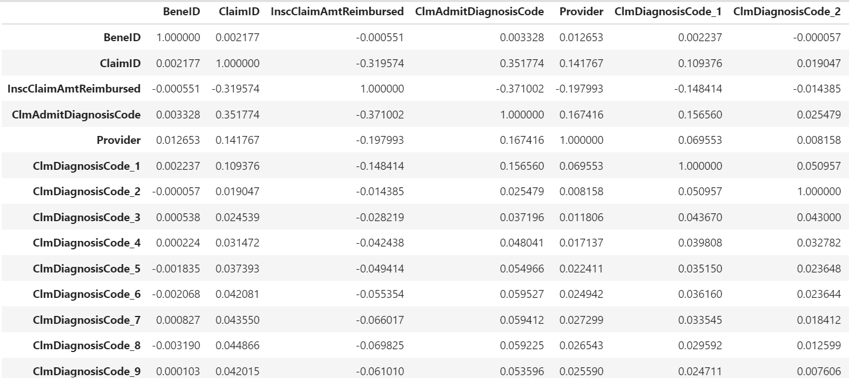

**Figure 5:** EDA Analysis (Correlation of Claim amount with other features)

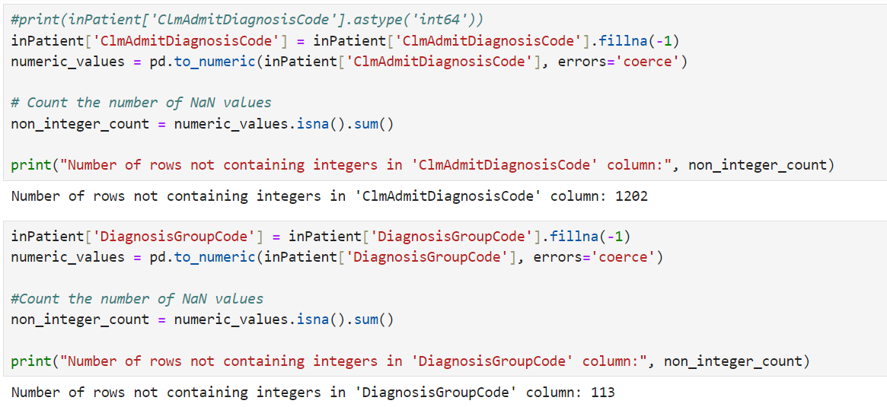

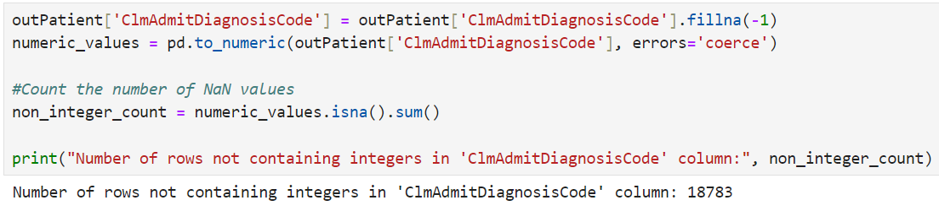

**Figure 6:** EDA

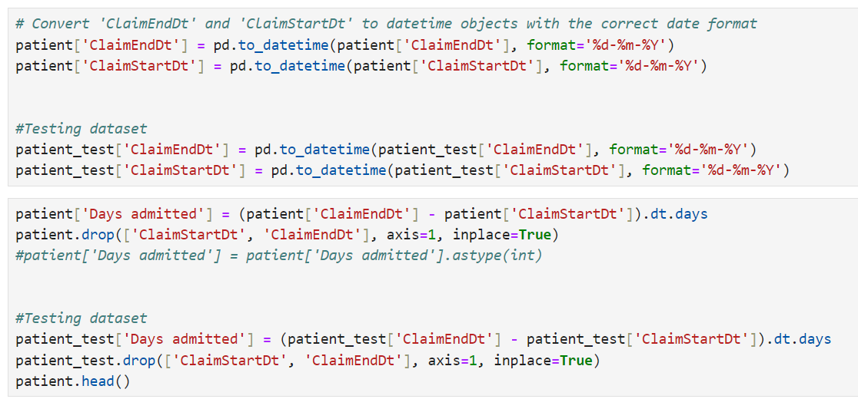

**Figure 7:** Conversion of data types and new column addition

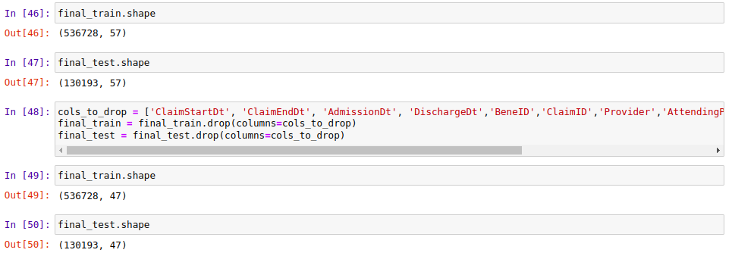

**Figure 8:** Removing Columns Unfit for Analysis

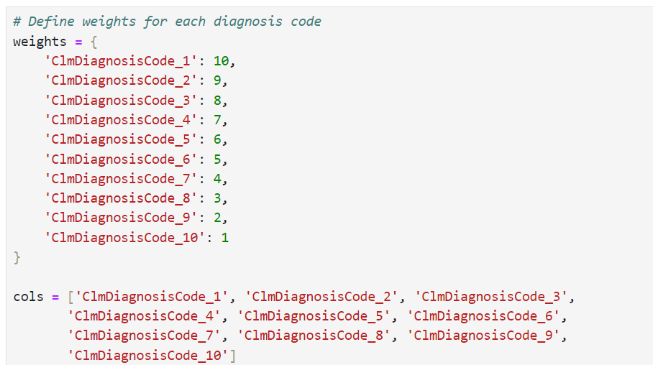

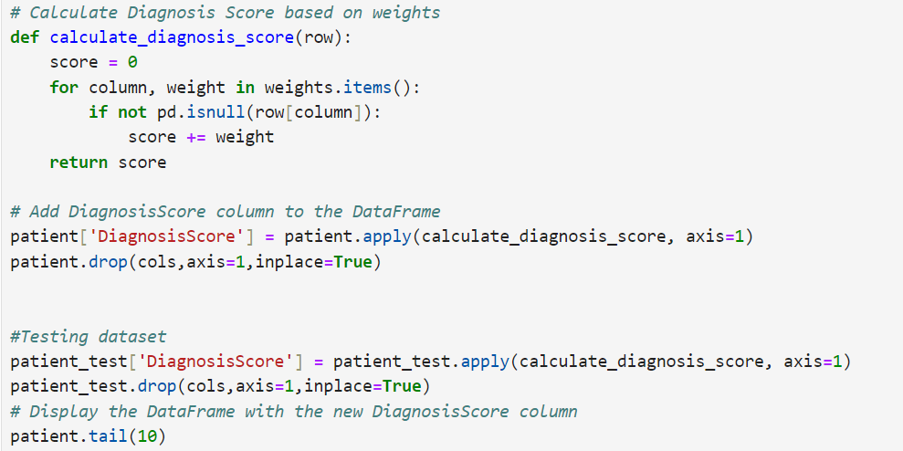

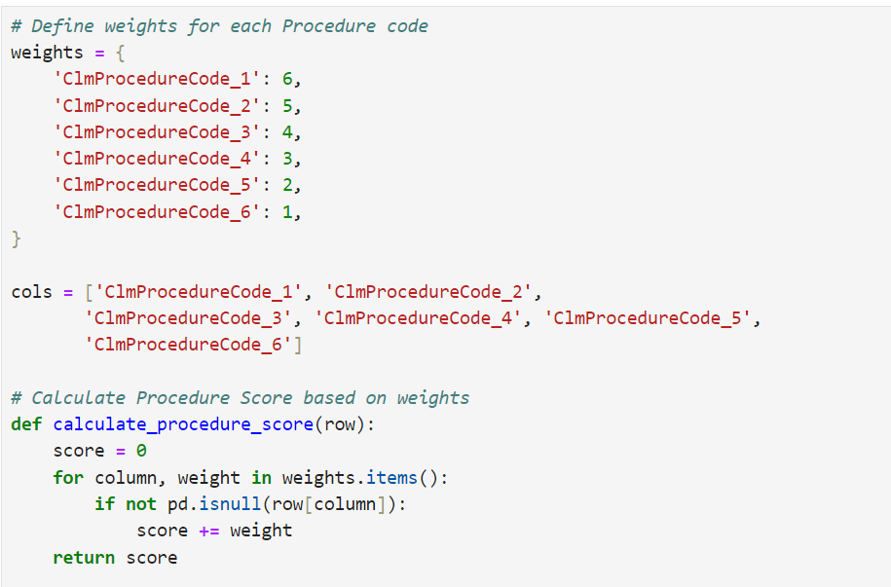

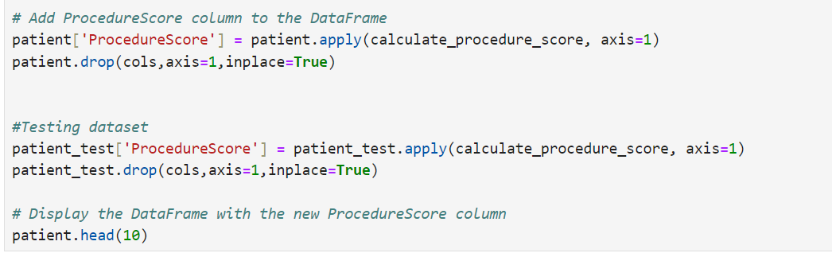

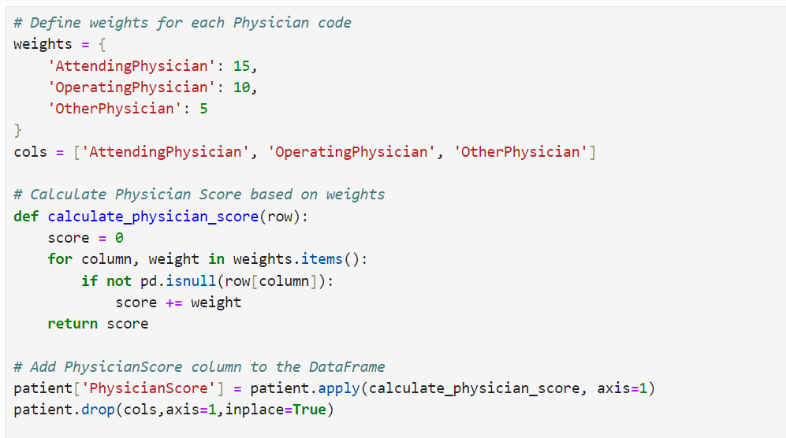

**Figure 10:** Weights and score calculation for new columns.

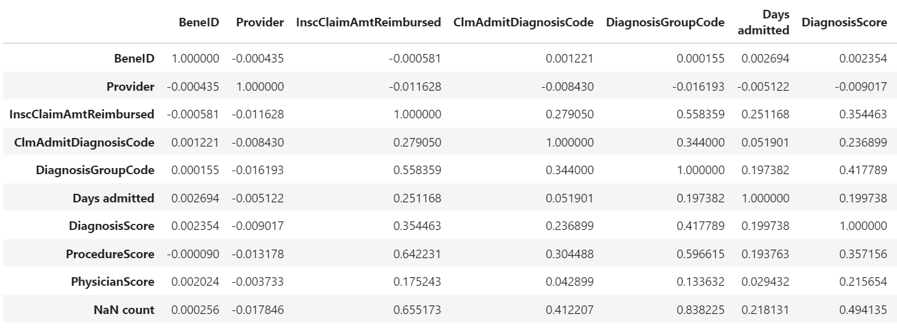

**Figure 11:** Displaying improved Correlation with new added columns.

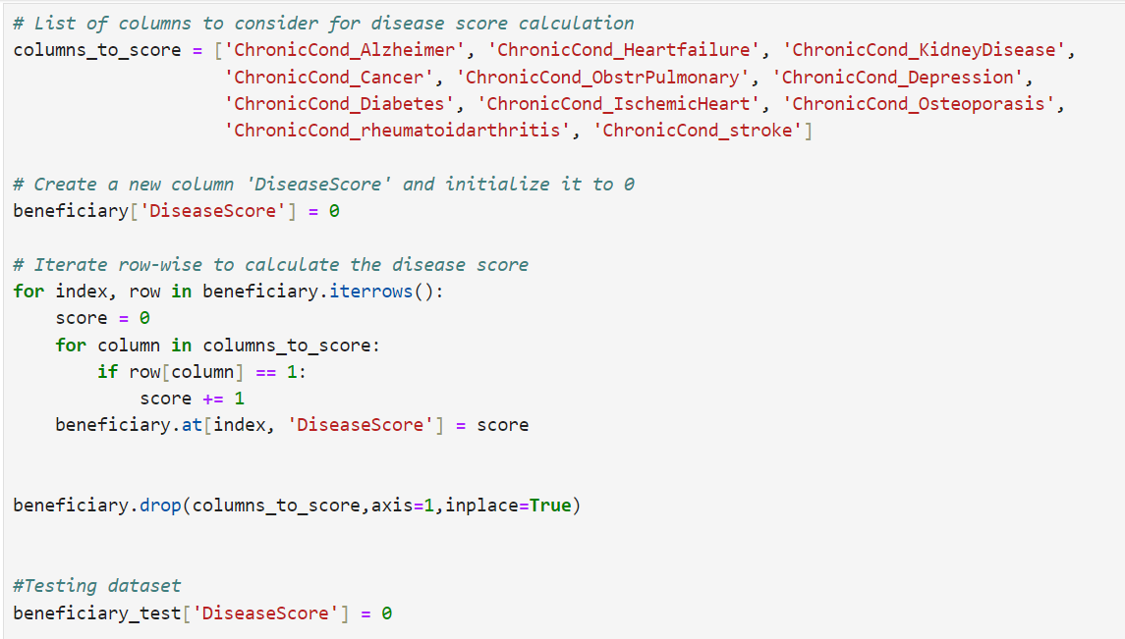

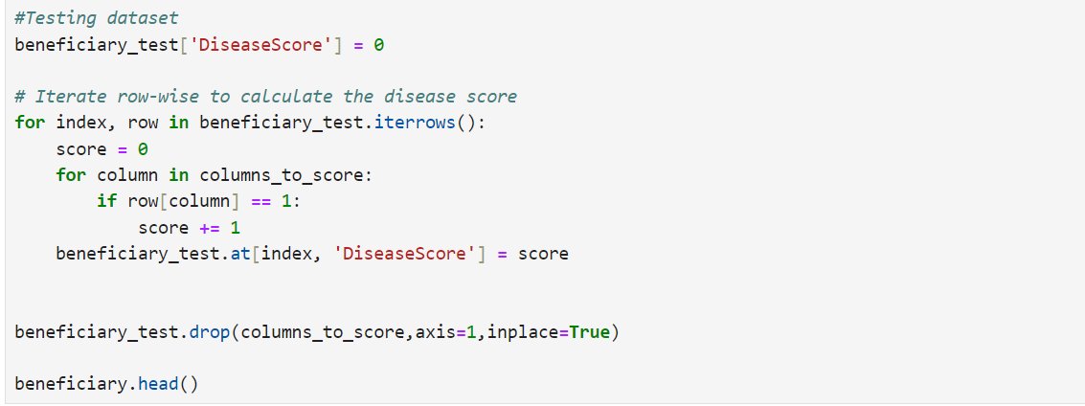

**Figure 12:** Disease Score calculation from beneficiary data.

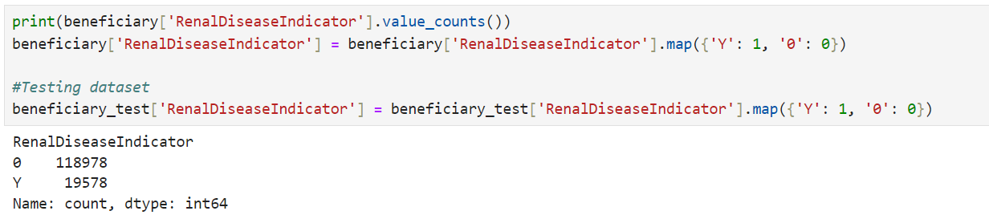

**Figure 13:** Mapping of Renal Disease indicator column.

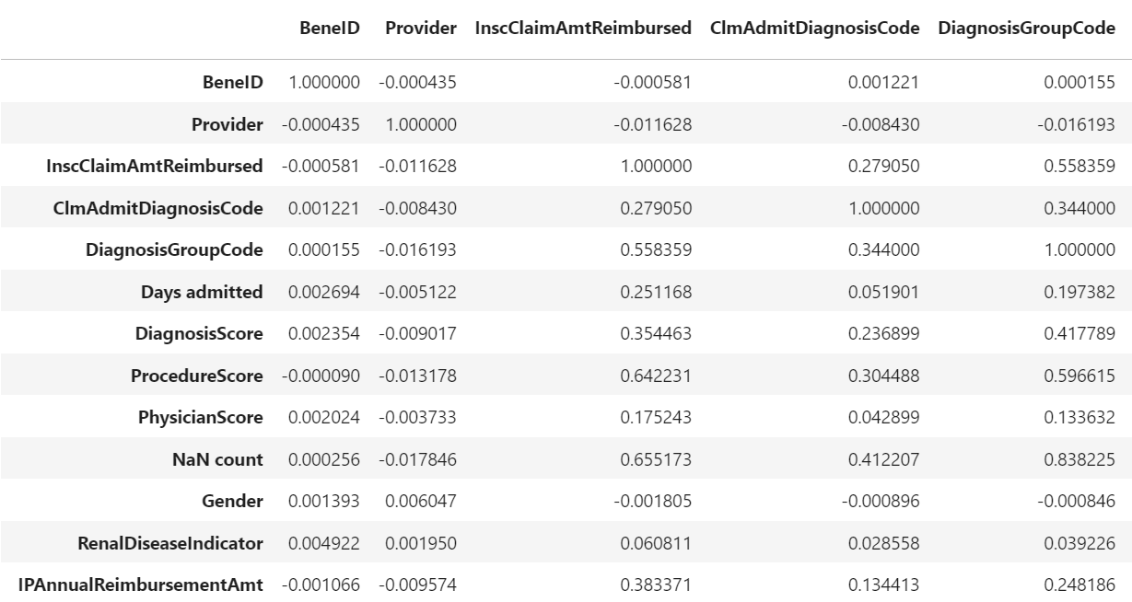

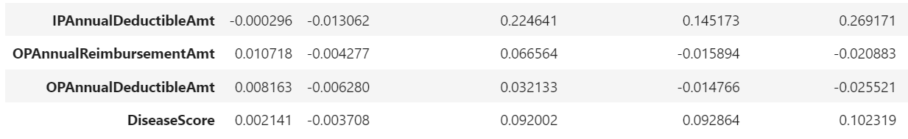

**Figure 14:** Final Correlation Analysis

With the above steps, I have completed the Exploratory Data Analysis (EDA) to obtain the required training and testing datasets for model prediction.

**Task 2:** Build a predictive model to estimate claim amounts.

**Deliverable 2:** A trained predictive model.

*Research and Approach Planning*

**Machine Learning Model Selection and Exploration**

This section details the selection and exploration of various machine learning models employed to predict claim outcomes within the historical claims data. The chosen models were evaluated based on their suitability for regression tasks and their ability to handle the specific characteristics of the data, including the presence of both numerical and categorical features.

**Model Descriptions:**

* **XGBoost Regressor:** This implementation of gradient boosted decision trees is known for its speed and accuracy. It constructs a sequence of decision trees, each refining the predictions of the previous trees, ultimately aiming to improve overall prediction accuracy. Regularization techniques are incorporated to prevent overfitting, and various hyperparameters can be tuned to optimize its performance.
* **Random Forest Regressor:** This ensemble method utilizes multiple decision trees for regression. During training, it builds a collection of decision trees and leverages the average prediction of these individual trees for the final output. Random forests are particularly effective with large, high-dimensional datasets and demonstrate greater resistance to overfitting compared to single decision trees. Their capability to capture intricate data relationships and handle noise makes them widely applicable across various domains.
* **Gradient Boosting Regressor:** This algorithm builds an ensemble of decision trees to create a powerful predictive model. It accomplishes this by sequentially adding new models, each focused on correcting the errors of the existing models within the ensemble. Each new addition trains on the residual errors of the ensemble's predictions, progressively improving overall prediction accuracy. Gradient Boosting Regressors are renowned for their high performance and adeptness at handling complex, non-linear data relationships.
* **CatBoost Regressor:** Designed specifically for tabular data containing categorical features, CatBoost utilizes gradient boosting techniques similar to XGBoost and LightGBM. However, it incorporates optimizations specifically tailored to handle categorical variables, eliminating the need for extensive pre-processing steps like one-hot encoding. This allows CatBoost to automatically manage categorical features, streamlining the model development process. It is recognized for its high performance and is a popular choice for both competitions and real-world applications.

The selection of these models provides a robust foundation for exploring various approaches to claim outcome prediction within the historical claims data. The subsequent sections will delve into the training, evaluation, and comparison of these models to identify the most effective solution for this specific use case.

*Development and Demonstration*

I have calculated the accuracy of each model to predict the claim amount reimbursed.

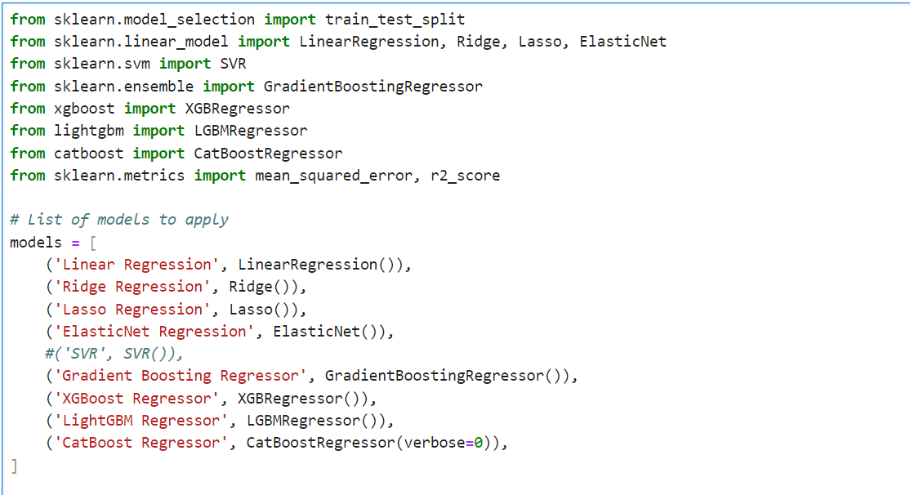

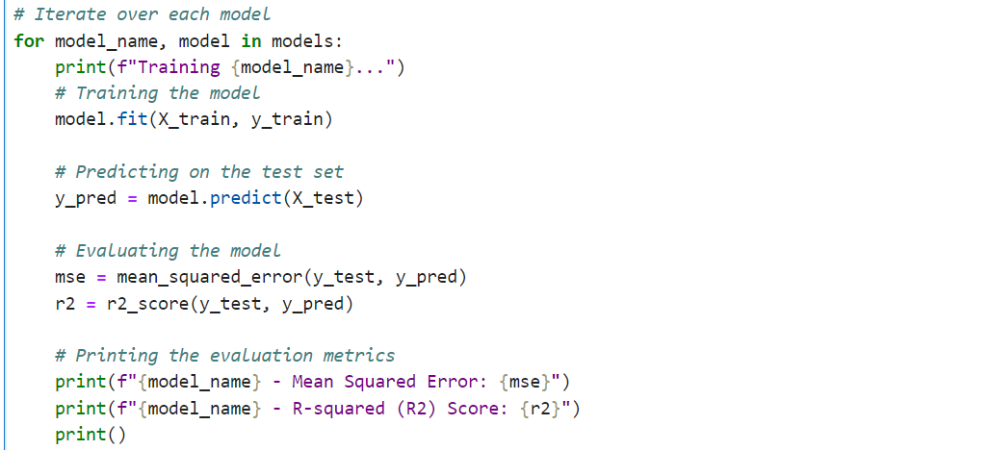

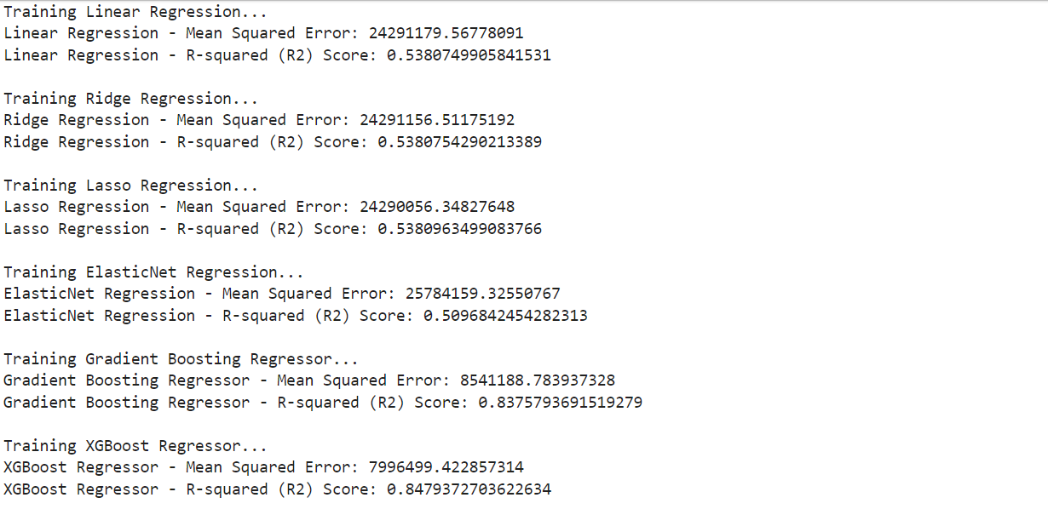

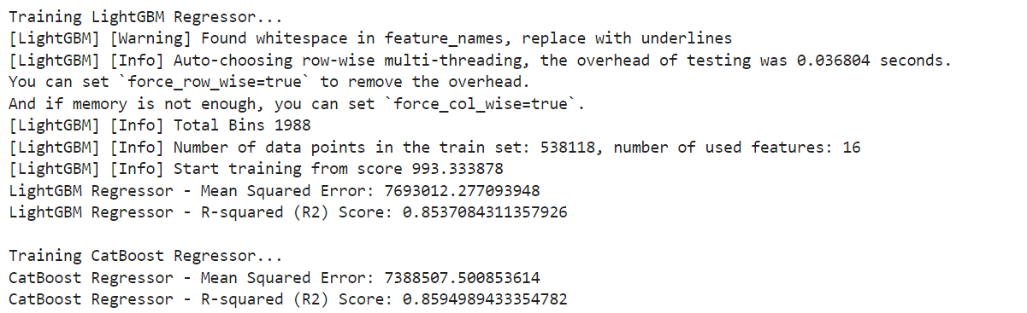

**Figure 18:** Training multiple models and choosing the best model for this fit.

***Model Deployment and API***

**Task 3:** Serialize the trained claim prediction model.

**Deliverable 3:** A serialized model file ready for deployment.

*Research and Approach Planning*

**Model Persistence with Pickle**

This section details the process of employing the Pickle module for model persistence within the project. Pickle offers a convenient approach to serialize and deserialize Python objects, including machine learning models. This functionality proves particularly advantageous in the context of machine learning, as it allows us to:

* **Save Trained Models:** Persist trained models to disk as byte streams. This enables us to reuse these models in the future without the need for retraining from scratch, saving significant time and computational resources.
* **Enhance Reusability:** Facilitate the reuse of models across different applications or environments by readily loading them from serialized files.
* **Streamline Model Sharing:** Enable the sharing of models with collaborators or deployment to production environments by transmitting the serialized byte stream.

**Model Serialization and Deserialization**

The process leverages Pickle to serialize the CatBoost model, which demonstrated superior accuracy in the previous analysis. Serialization essentially converts the complex model object into a byte stream, suitable for storage in a file or transmission over a network. Subsequently, the serialized byte stream can be loaded back into memory using Pickle's deserialization functionality, effectively recreating the original model object in its entirety.

**Demonstration of Persistence**

To illustrate this process, the CatBoost model is first serialized and saved as a pickle file. This file stores the model in a compact, byte-stream format. Following this, the serialized byte stream is loaded back into memory using Pickle's deserialization capabilities. This allows us to utilize the previously trained model for making predictions on new data, demonstrating the effectiveness of Pickle in model persistence.

By employing Pickle for model persistence, we ensure the efficient storage, retrieval, and reusability of our trained models, promoting streamlined development workflows and fostering collaboration within the project.

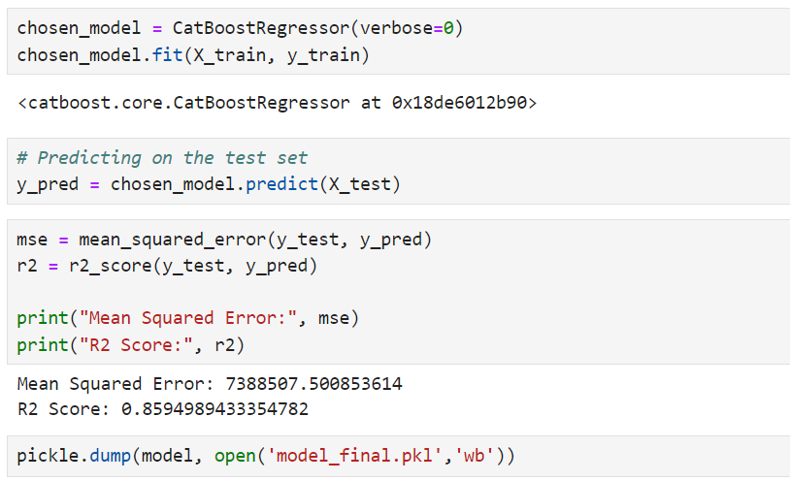

**Figure 20:** Dumping the model and creating a pickle file.

**Task 4:** Deploy the model as a service with an API for integration.

**Deliverable 4:** A functional API with endpoints for making predictions.

*Research and Approach Planning*

**API Development and User Interface Design**

This section details the development of the application's core functionalities: the backend API and the user interface (UI).

**FastAPI: Building the Backend API**

FastAPI, a high-performance web framework for Python, was chosen to construct the project's backend API. Here's how FastAPI contributes to the project:

* **Efficiency and Scalability:** FastAPI is designed for speed and efficiency, making it well-suited for handling high volumes of user requests. It leverages asynchronous programming techniques to minimize resource consumption while maintaining responsiveness.
* **Automatic API Documentation:** FastAPI automatically generates interactive API documentation (Swagger UI) based on the code's type hints. This documentation proves invaluable for understanding and testing the API, streamlining both development and integration processes.
* **Robust Features:** FastAPI offers a comprehensive feature set including dependency injection, request validation, and data serialization. These features contribute to the construction of robust and scalable web APIs, ensuring reliable and secure operation.

By leveraging FastAPI's strengths, we were able to establish a robust and efficient backend API capable of effectively handling model inference requests and delivering predictions to the user interface.

**Streamlit: Crafting the User Interface**

Streamlit, a user-friendly framework for building data apps in Python, was employed to design the application's user interface (UI). Streamlit facilitates the creation of interactive and visually appealing interfaces, allowing users to seamlessly interact with the model. Here's how Streamlit benefits the project:

* **Simplified Development:** Streamlit offers a streamlined development process, enabling the creation of UIs with minimal coding effort. This allows for rapid UI prototyping and iteration, fostering efficient development cycles.
* **Interactive Features:** Streamlit supports the development of interactive UI components, such as input fields and data visualizations. These elements empower users to engage with the model in a meaningful way, providing a user-centric experience.
* **Deployment Potential:** Streamlit applications can be readily deployed to various platforms, making it easier to share the application with stakeholders and integrate it into existing workflows.

By adopting Streamlit, we were able to construct a user-friendly and interactive UI that serves as the primary point of interaction for users seeking model predictions. The combination of FastAPI's robust backend and Streamlit's intuitive UI creates a cohesive application experience.

*Development*

I have written a python script to create the API endpoint on swagger and used Streamlit to display the results on frontend.

Python script using UVicorn and FastAPI:

import uvicorn

from fastapi import FastAPI

from patientInfo import p_info

import numpy as np

import pickle

import pandas as pd

#Creating the app object

app = FastAPI()

pickle_in = open("model_final.pkl","rb")

classifier = pickle.load(pickle_in)

# Index route, opens automatically on http://127.0.0.1:8000

@app.get('/')

def index():

    return {'message': "Hello, Welcome to Suryas Claims prediction assignment"}

@app.get('/{name}')

def get_name(name: str):

    return {'message': f'Hello, {name}'}

#Code to get Disease Score

from patientInfo import diseaseScore

@app.post('/disease_score')

async def diseaseSc(payload : diseaseScore):

    data = payload.__dict__

    print(data)

    # print("Hello")

    # Extract values from the dictionary

    features = [data[field] for field in diseaseScore.model_fields.keys()]

    count = 10

    score = 0

    for feature in features:

        if(feature == 1):

            score += count

        count -= 1

    print("Your disease score is : ", score)

    return {

        'Desease Score' : score

    }

#Code to get Physician Score

from patientInfo import PhysicianScore

@app.post('/physician_score')

async def PhysicianSc(payload : PhysicianScore):

    data = payload.__dict__

    print(data)

    # print("Hello")

    # Extract values from the dictionary

    features = [data[field] for field in PhysicianScore.model_fields.keys()]

    count = 15

    score = 0

    for feature in features:

        if(feature == 1):

            score += count

        count -= 5

    print("Your Physician score is : ", score)

    return {

        'Physician Score' : score

    }

#Code to get Procedure Score

from patientInfo import ProcedureScore

@app.post('/procedure_score')

async def PhysicianSc(payload : ProcedureScore):

    data = payload.__dict__

    print(data)

    # Extract values from the dictionary

    features = [data[field] for field in ProcedureScore.model_fields.keys()]

    count = 6

    score = 0

    for feature in features:

        if(feature == 1):

            score += count

        count -= 1

    print("Your Procedure score is : ", score)

    return {

        'Procedure Score' : score

    }

#Code to get Procedure Score

from patientInfo import DiagnosisScore

@app.post('/diagnosis_score')

async def PhysicianSc(payload : DiagnosisScore):

    data = payload.__dict__

    print(data)

    # Extract values from the dictionary

    features = [data[field] for field in DiagnosisScore.model_fields.keys()]

    count = 10

    score = 0

    for feature in features:

        if(feature == 1):

            score += count

        count -= 1

    print("Your Diagnosis score is : ", score)

    return {

        'Diagnosis Score' : score

    }

@app.post('/predict')

async def predict(payload : p_info):

    data = payload.__dict__

    print(data)

    # Extract values from the dictionary

    features = [data[field] for field in p_info.model_fields.keys()]

    # Make prediction

    prediction = classifier.predict([features])[0]

    print("Predicted insurance amount is : ", prediction)

    return {

        'Prediction' : prediction

    }

# Running the API with uvicorn

if __name__ == '__main__':

    uvicorn.run(app,host='127.0.0.1', port=8000)

Schema file

from pydantic import BaseModel

class p_info(BaseModel):

    BeneID : int

    Provider : int

    InscClaimAmtReimbursed : int

    ClmAdmitDiagnosisCode : int

    DiagnosisGroupCode : int

    Days_admitted : int

    DiagnosisScore : int

    ProcedureScore : int

    PhysicianScore : int

    NaN_count : int

    Total_Score : int

    Gender : int

    RenalDiseaseIndicator : int

    IPAnnualReimbursementAmt : int

    IPAnnualDeductibleAmt : int

    OPAnnualReimbursementAmt : int

    OPAnnualDeductibleAmt : int

    DiseaseScore : int

class diseaseScore(BaseModel):

    ChronicCond_Alzheimer : int

    ChronicCond_Heartfailure : int

    ChronicCond_KidneyDisease : int

    ChronicCond_Cancer : int

    ChronicCond_ObstrPulmonary : int

    ChronicCond_Depression : int

    ChronicCond_Diabetes : int

    ChronicCond_IschemicHeart : int

    ChronicCond_Osteoporasis : int

    ChronicCond_rheumatoidarthritis : int

    ChronicCond_stroke : int

class PhysicianScore(BaseModel):

    AttendingPhysician: int

    OperatingPhysician: int

    OtherPhysician: int

class ProcedureScore(BaseModel):

    ClmProcedureCode_1: int

    ClmProcedureCode_2: int

    ClmProcedureCode_3: int

    ClmProcedureCode_4: int

    ClmProcedureCode_5: int

    ClmProcedureCode_6: int

class DiagnosisScore(BaseModel):

    ClmDiagnosisCode_1: int

    ClmDiagnosisCode_2: int

    ClmDiagnosisCode_3: int

    ClmDiagnosisCode_4: int

    ClmDiagnosisCode_5: int

    ClmDiagnosisCode_6: int

    ClmDiagnosisCode_7: int

    ClmDiagnosisCode_8: int

    ClmDiagnosisCode_9: int

    ClmDiagnosisCode_10: int

*Demonstration*

I have deployed the API on render application,

<https://claimsapi-prediction.onrender.com/docs>

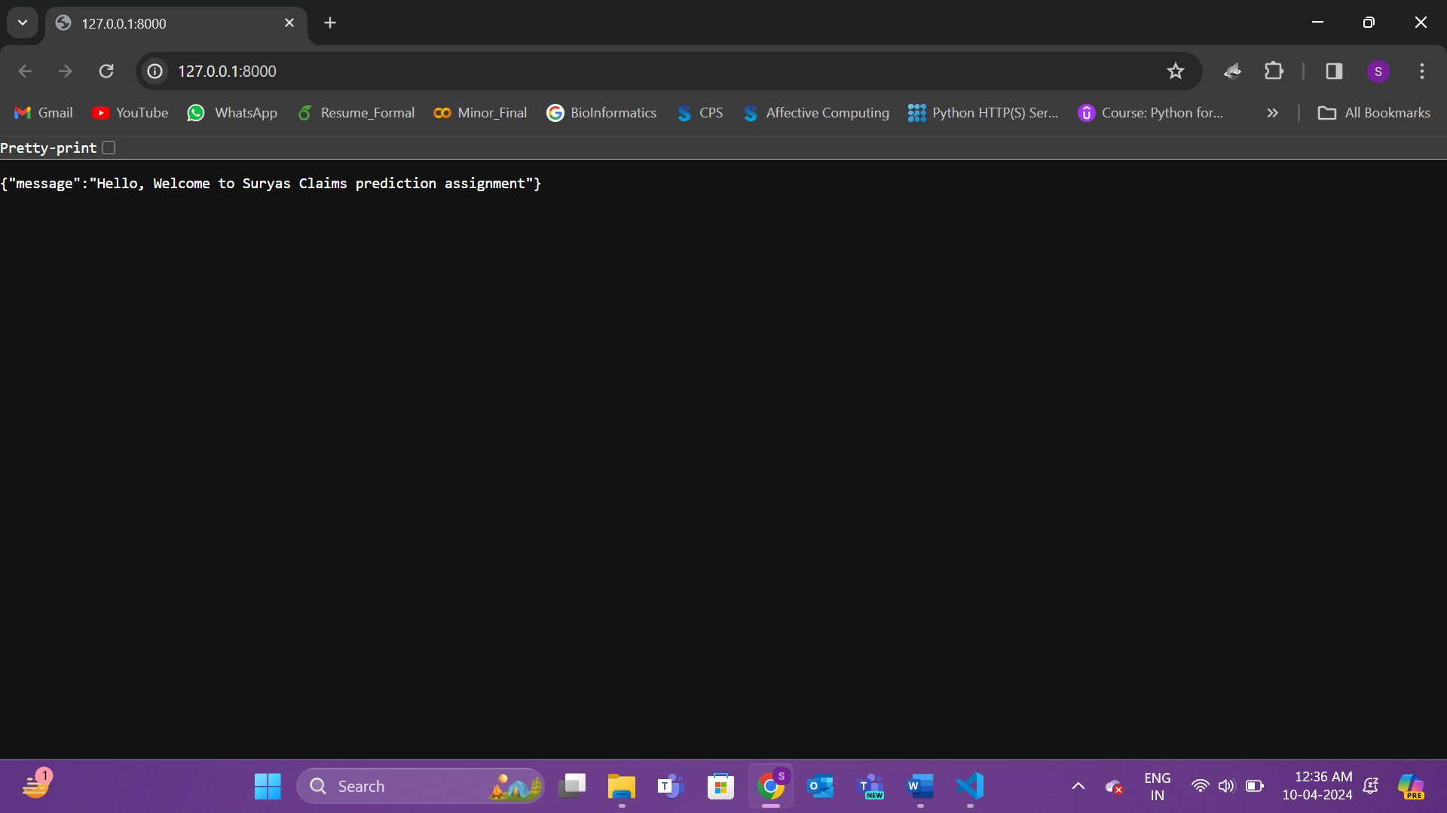

**Figure 21:** API Testing

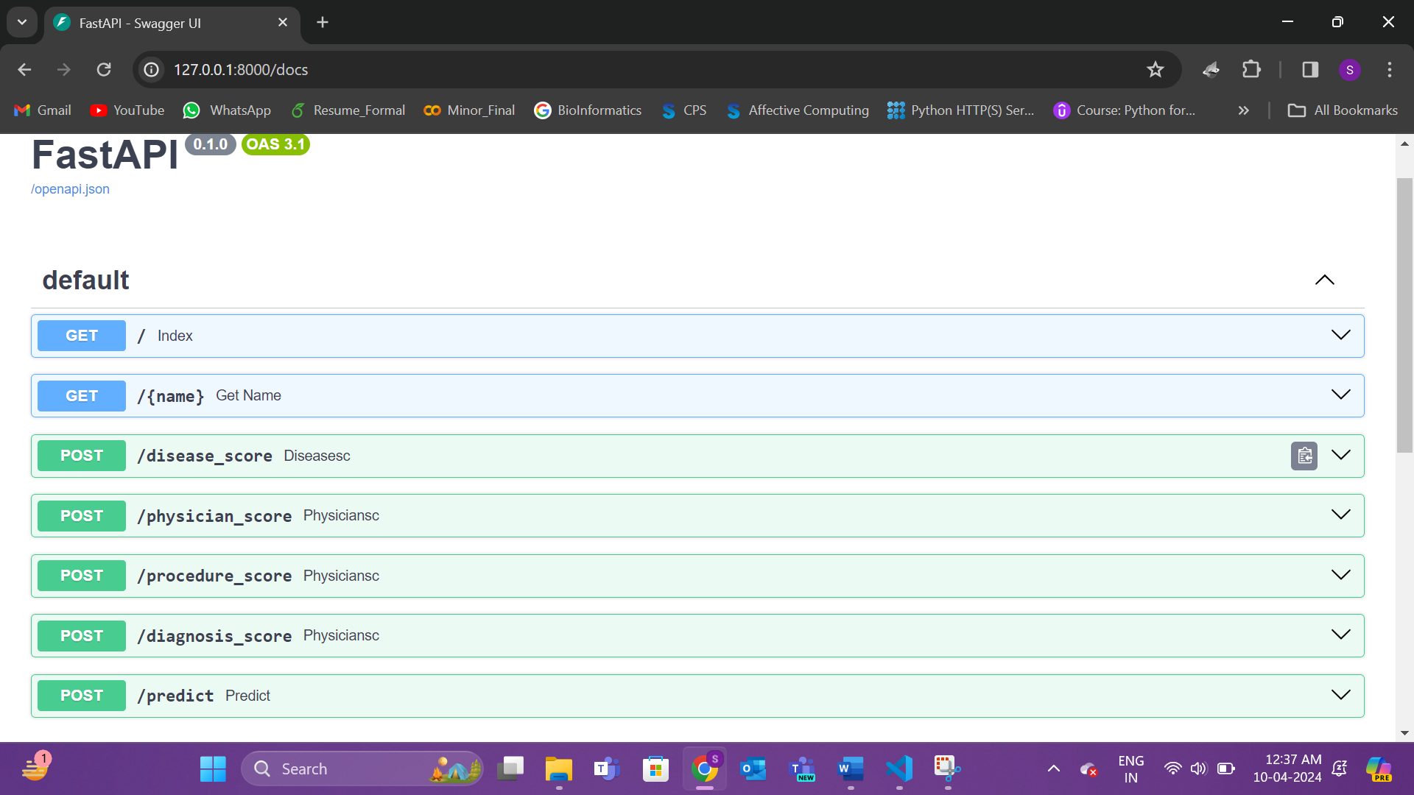

**Figure 22:** API Testing

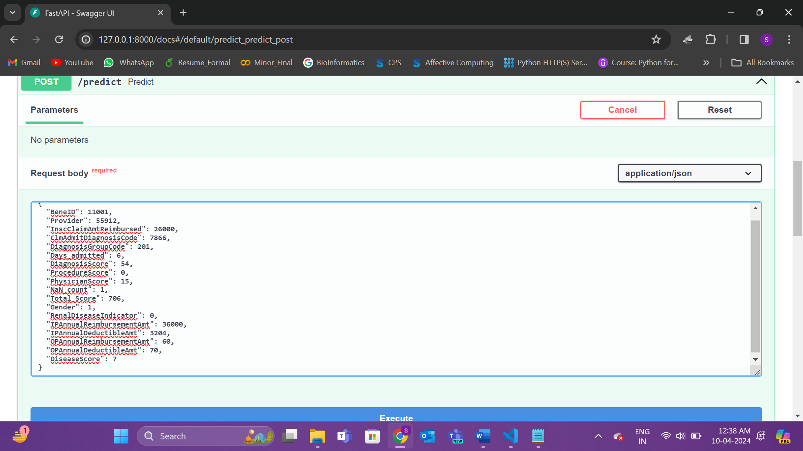

**Figure 23:** API Testing

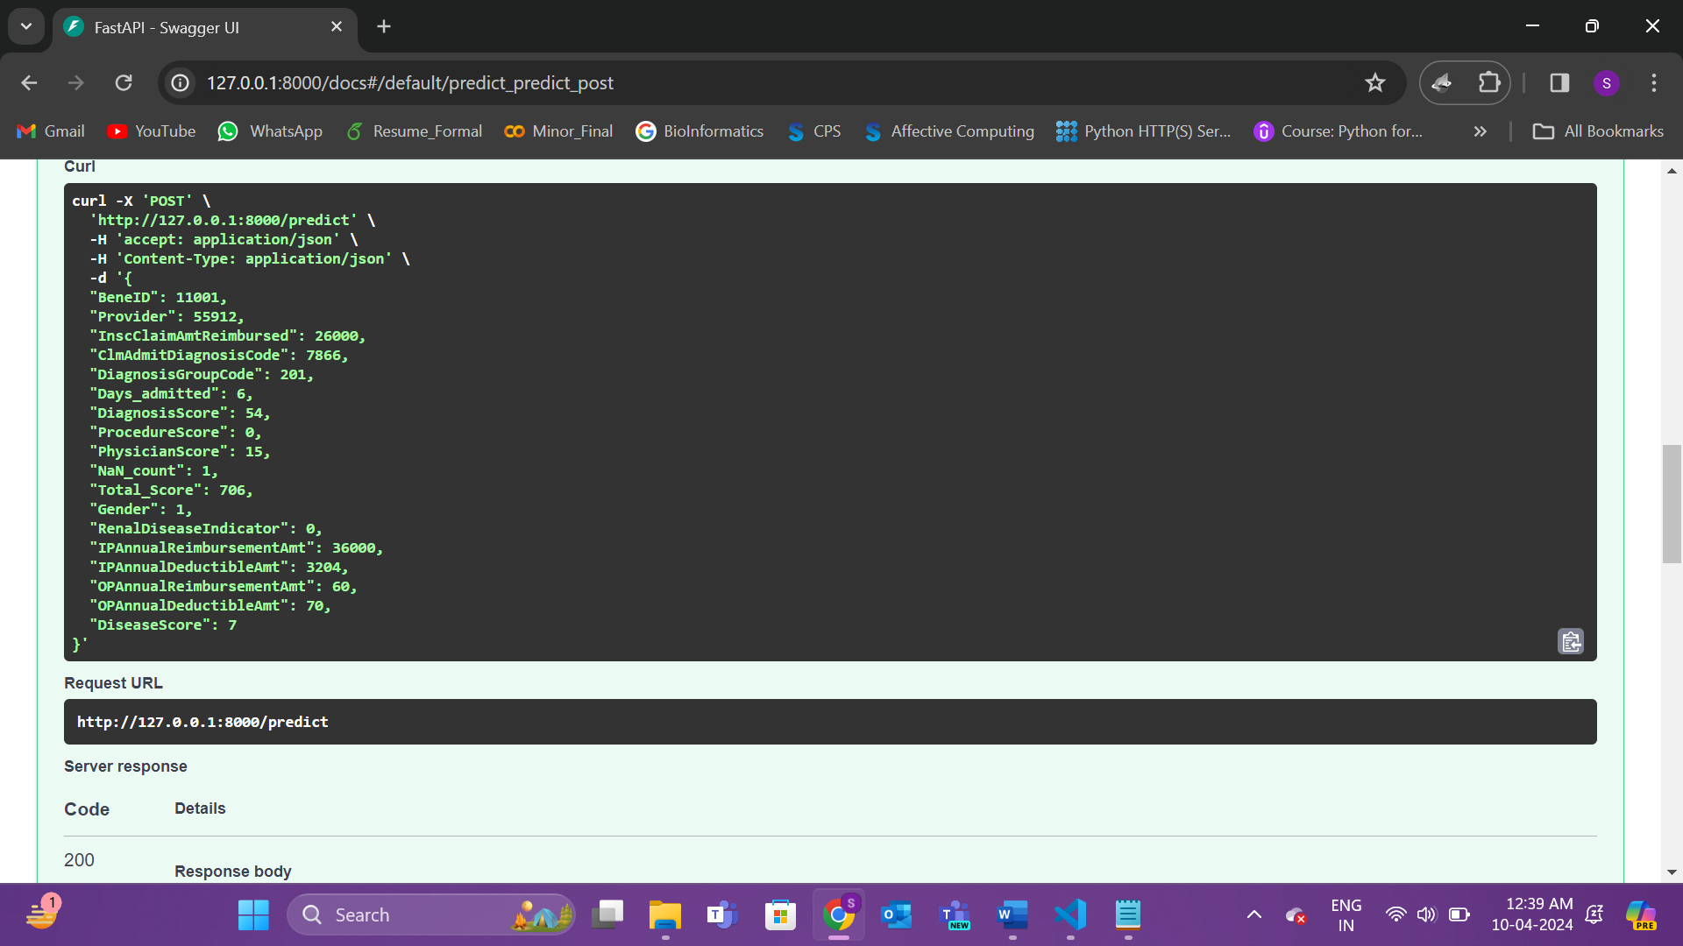

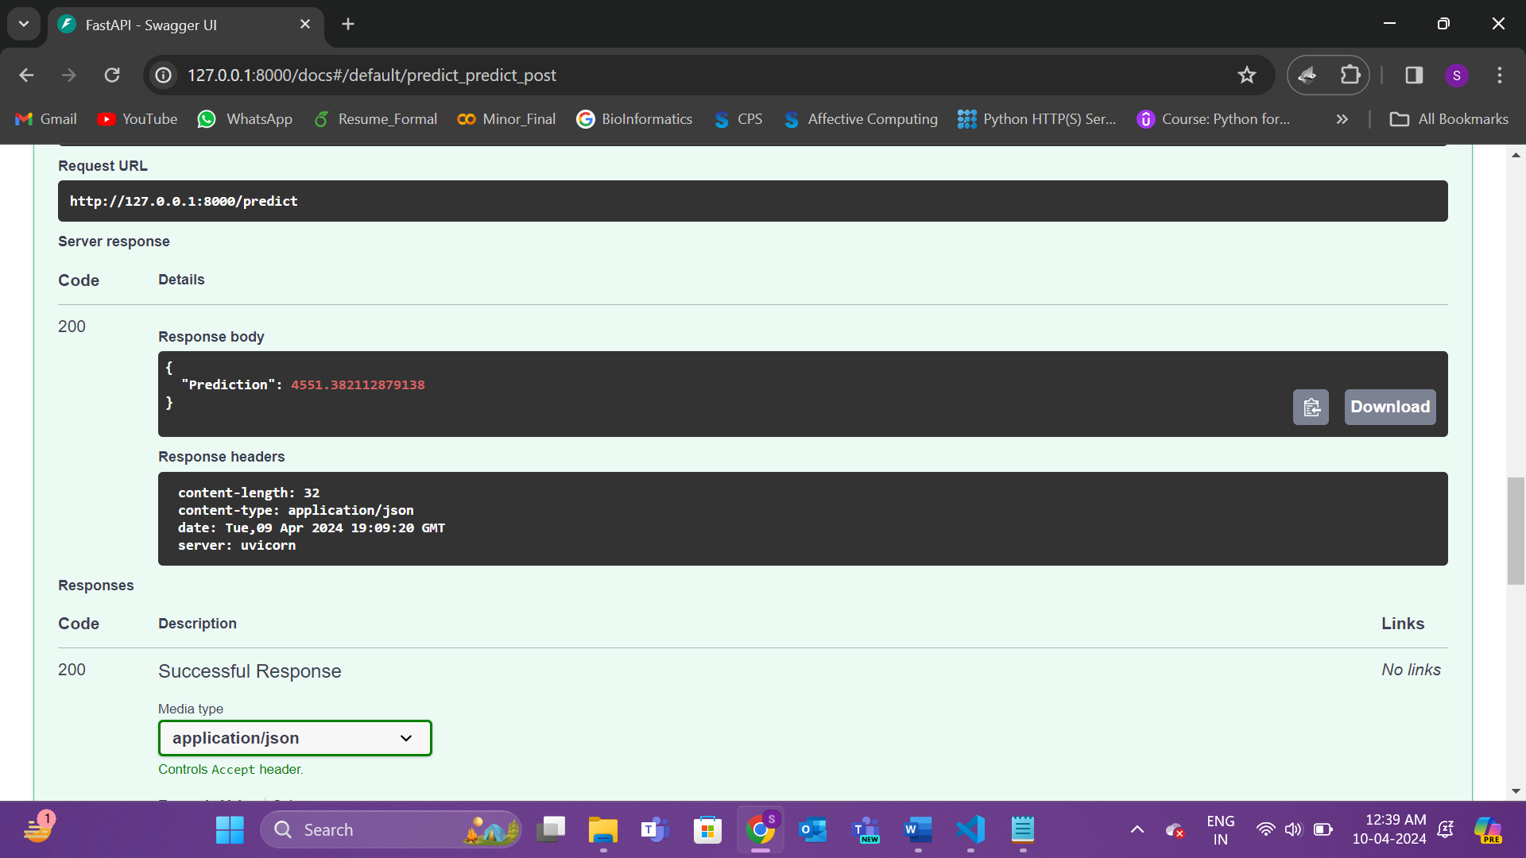

**Figure 24:** API Testing swagger





**Figure 25:** Claims Prediction App using StreamLit

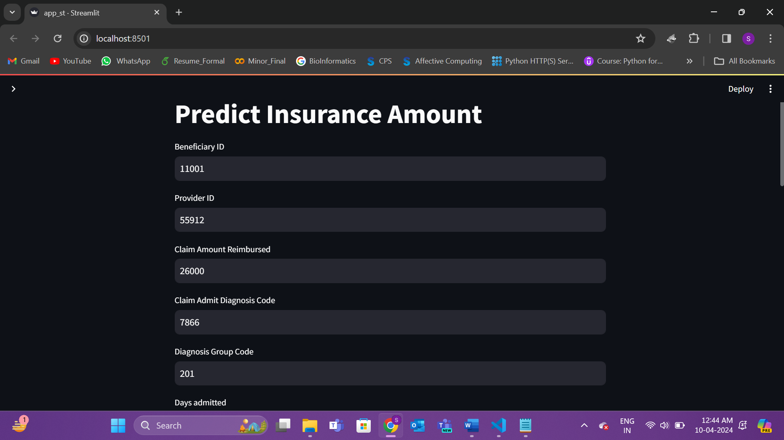

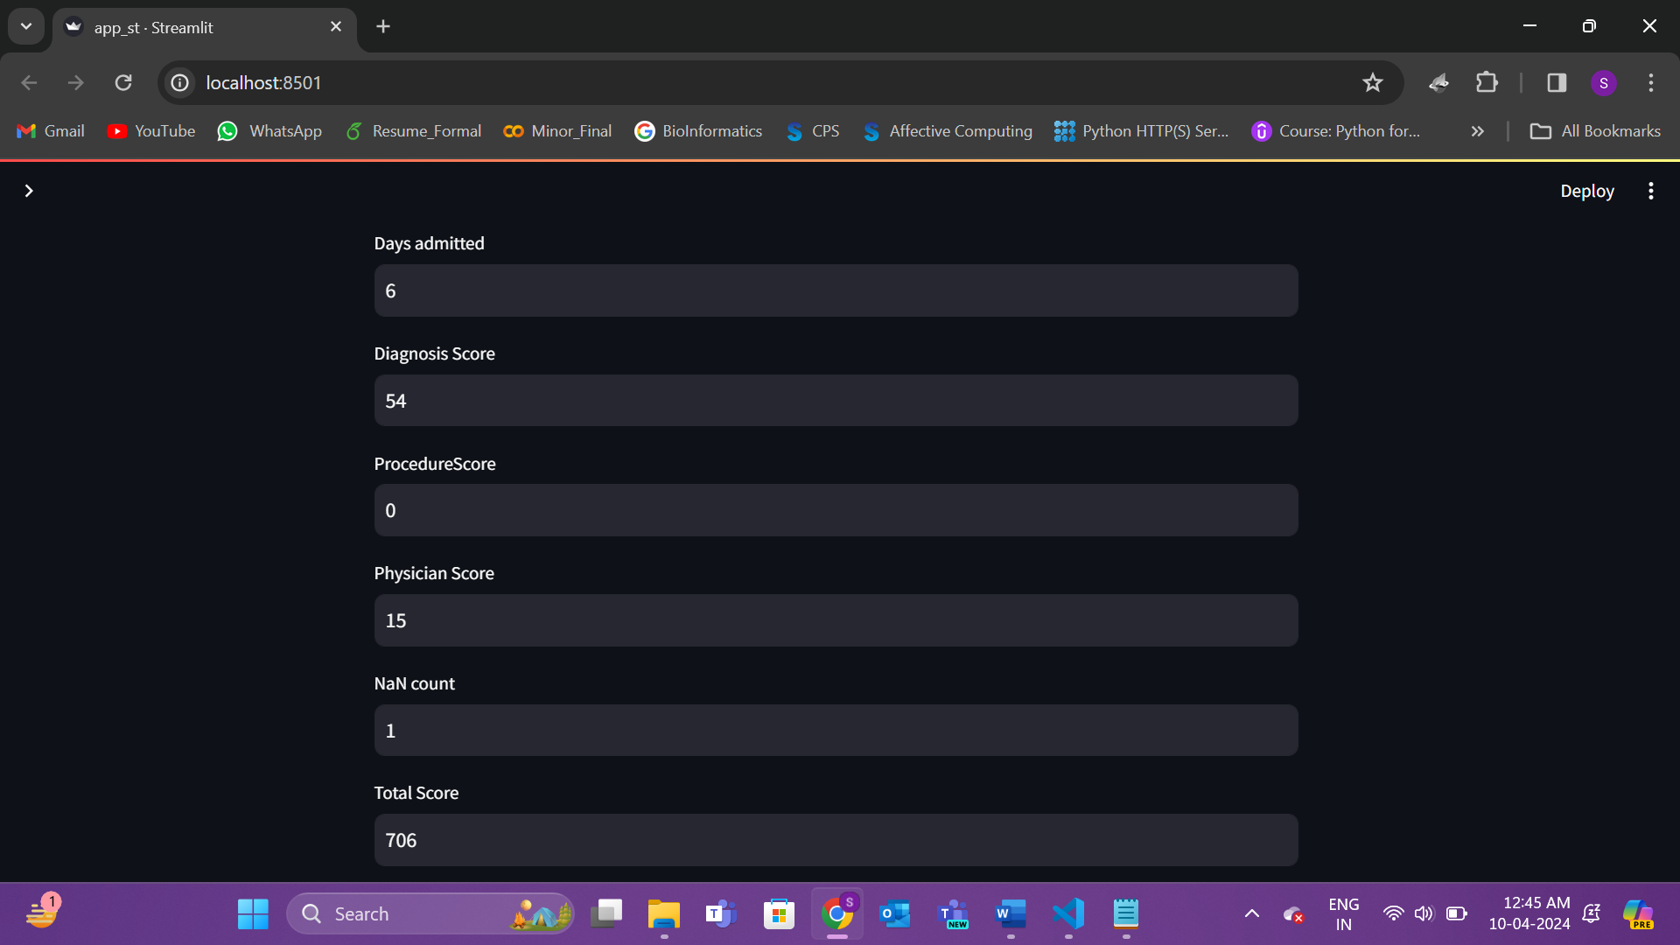

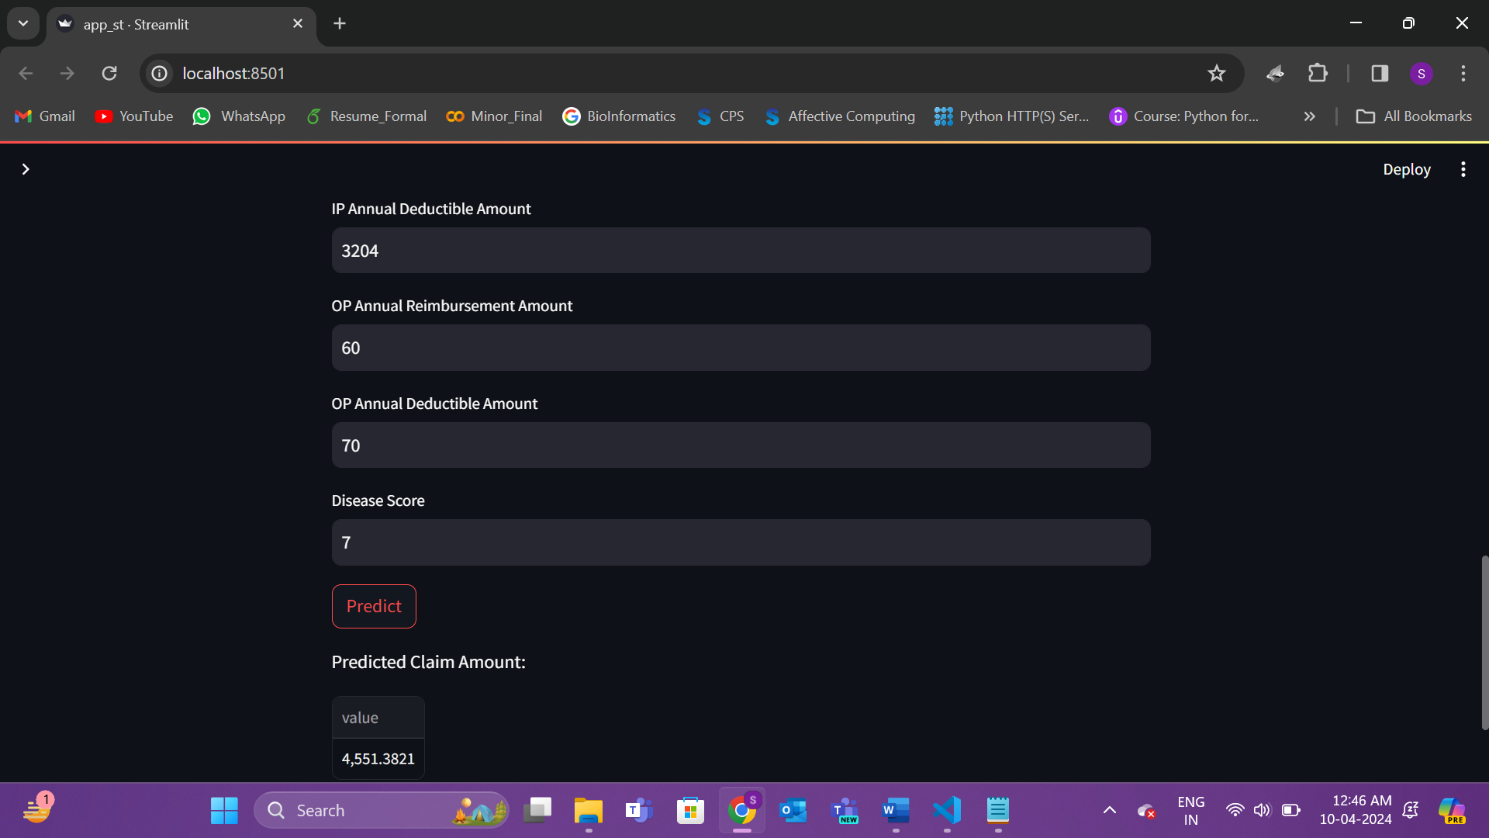

**Figure 26:** Claims Prediction App using StreamLit

***Continuous Learning Pipeline***

**Task 5:** Establish an automated data ingestion mechanism for the model.

**Deliverable 5:** An automated data ingestion system.

*Research and Approach Planning*

**Data Ingestion Pipeline with Azure Data Factory and Blob Storage**

This section details the data ingestion pipeline established to acquire and prepare historical claims data for analysis. The pipeline leverages two key Azure services: Azure Data Factory (ADF) and Azure Blob Storage.

* **Azure Data Factory (ADF):** An ADF pipeline was designed and implemented to orchestrate the data ingestion process. ADF serves as a cloud-based data integration service, offering functionalities for creating, scheduling, and managing data pipelines. Within this project, the ADF pipeline is responsible for:
  + **Extracting Data:** ADF retrieves data from its source location(s).
  + **Transforming Data:** The pipeline can perform basic data transformations on the extracted data to ensure its compatibility with subsequent analysis steps.
  + **Loading Data:** The transformed or raw data is then loaded into Azure Blob Storage for further processing or analysis.
* **Azure Blob Storage:** This highly scalable cloud storage solution provides a secure and reliable platform for storing the ingested data. Blob storage is ideally suited for handling large volumes of unstructured data, such as the historical claims data used in this project. By leveraging Blob Storage, we achieve the following benefits:
  + **Scalability:** Blob Storage seamlessly scales to accommodate growing data volumes, ensuring sufficient storage capacity for current and future needs.
  + **Cost-Effectiveness:** Blob Storage offers a cost-efficient solution for storing large datasets, making it an attractive option for various data management scenarios.
  + **Accessibility:** Data stored in Blob Storage remains readily accessible for further processing and analysis within the Azure environment.

The integration between ADF and Blob Storage establishes a robust and automated data ingestion pipeline. This pipeline ensures the consistent and efficient acquisition of historical claims data, providing the foundation for subsequent data exploration and model development.

*Demonstration*

I have stored the data in container by creating an Ingestion pipeline.

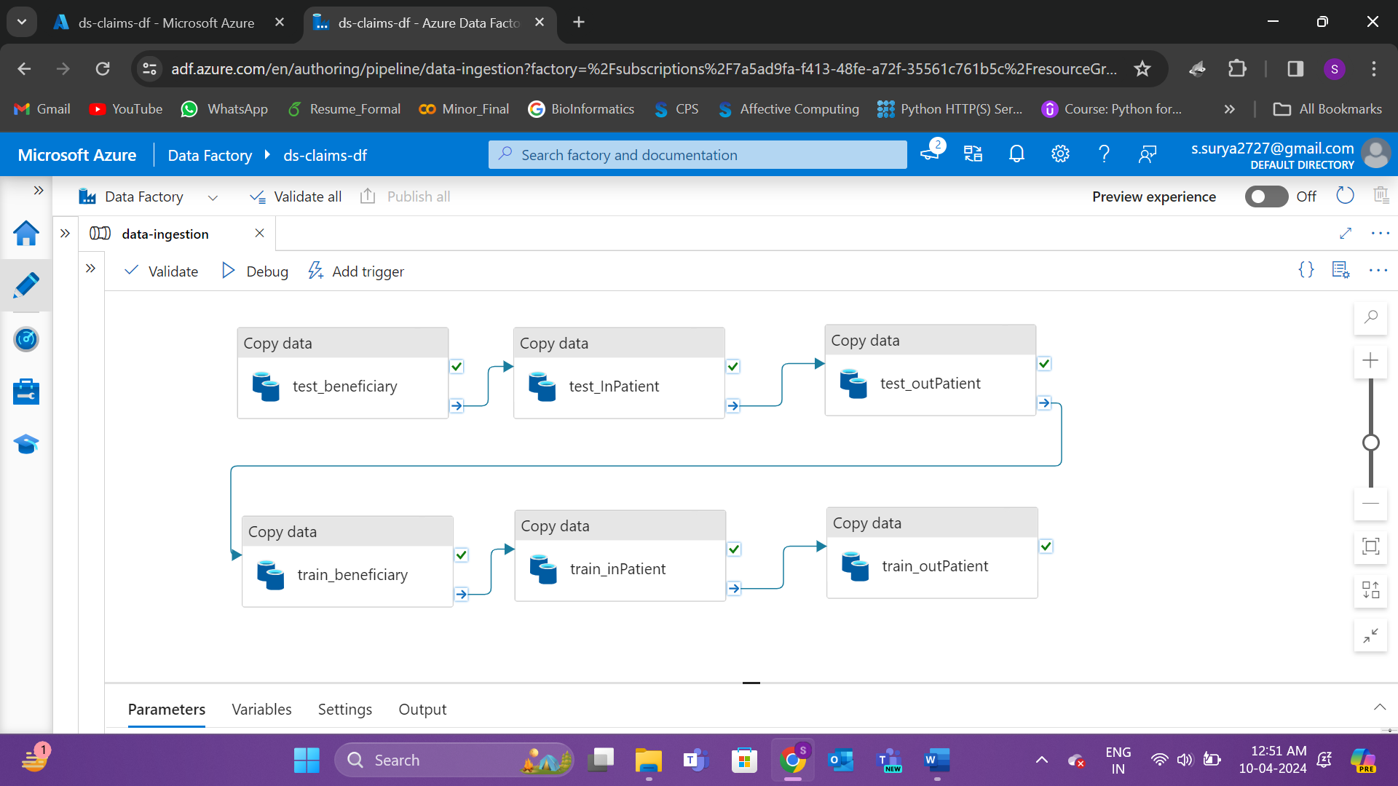

**Figure 26:** Data Ingestion Pipeline

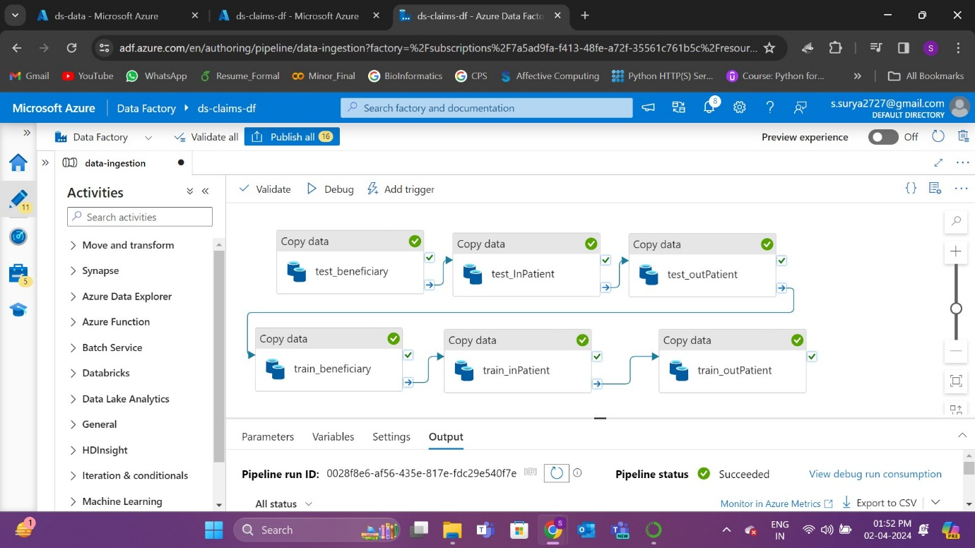

**Figure 27:** Data Ingestion pipeline status

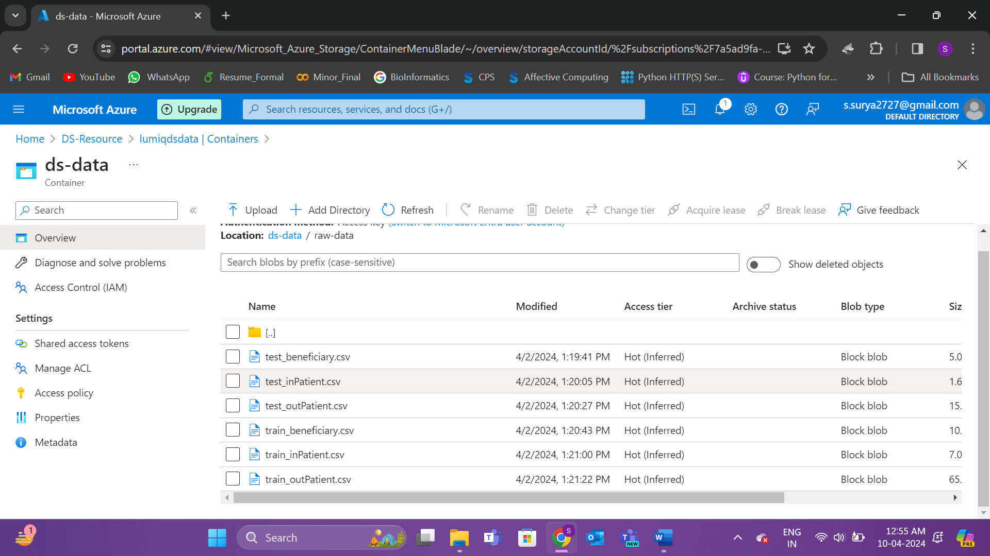

**Figure 28:** Raw data present in container

**Task 6:** Implement a continuous learning pipeline for model retraining.

**Deliverable 6:** A documented continuous learning and model retraining process.

*Research and Approach Planning*

I have used Azure Databricks to mount a CSV file containing Pandas data, allowing for seamless data preprocessing. The preprocessing steps were completed within the Databricks environment. Finally, the model was serialized and stored inside a container, ensuring easy deployment and reproducibility of the model.

*Demonstration*

I have mounted the data from container and implemented all the preprocessing inside databricks and then dumped the model inside container.

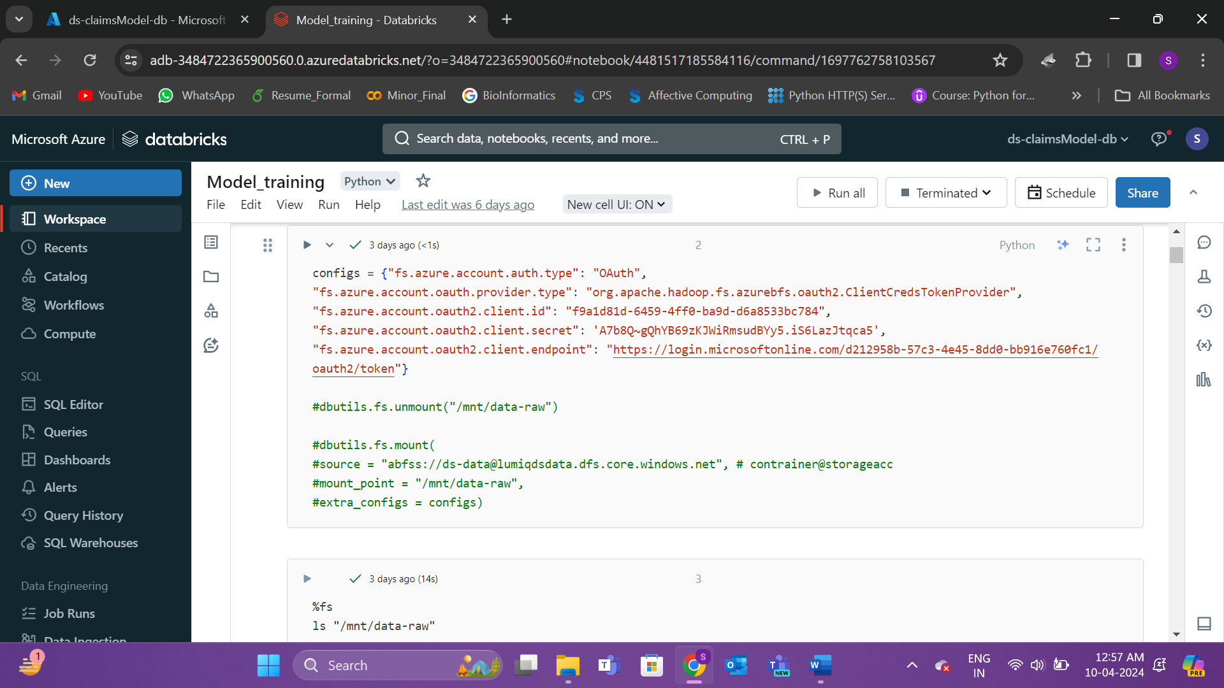

**Figure 29:** Connection with app

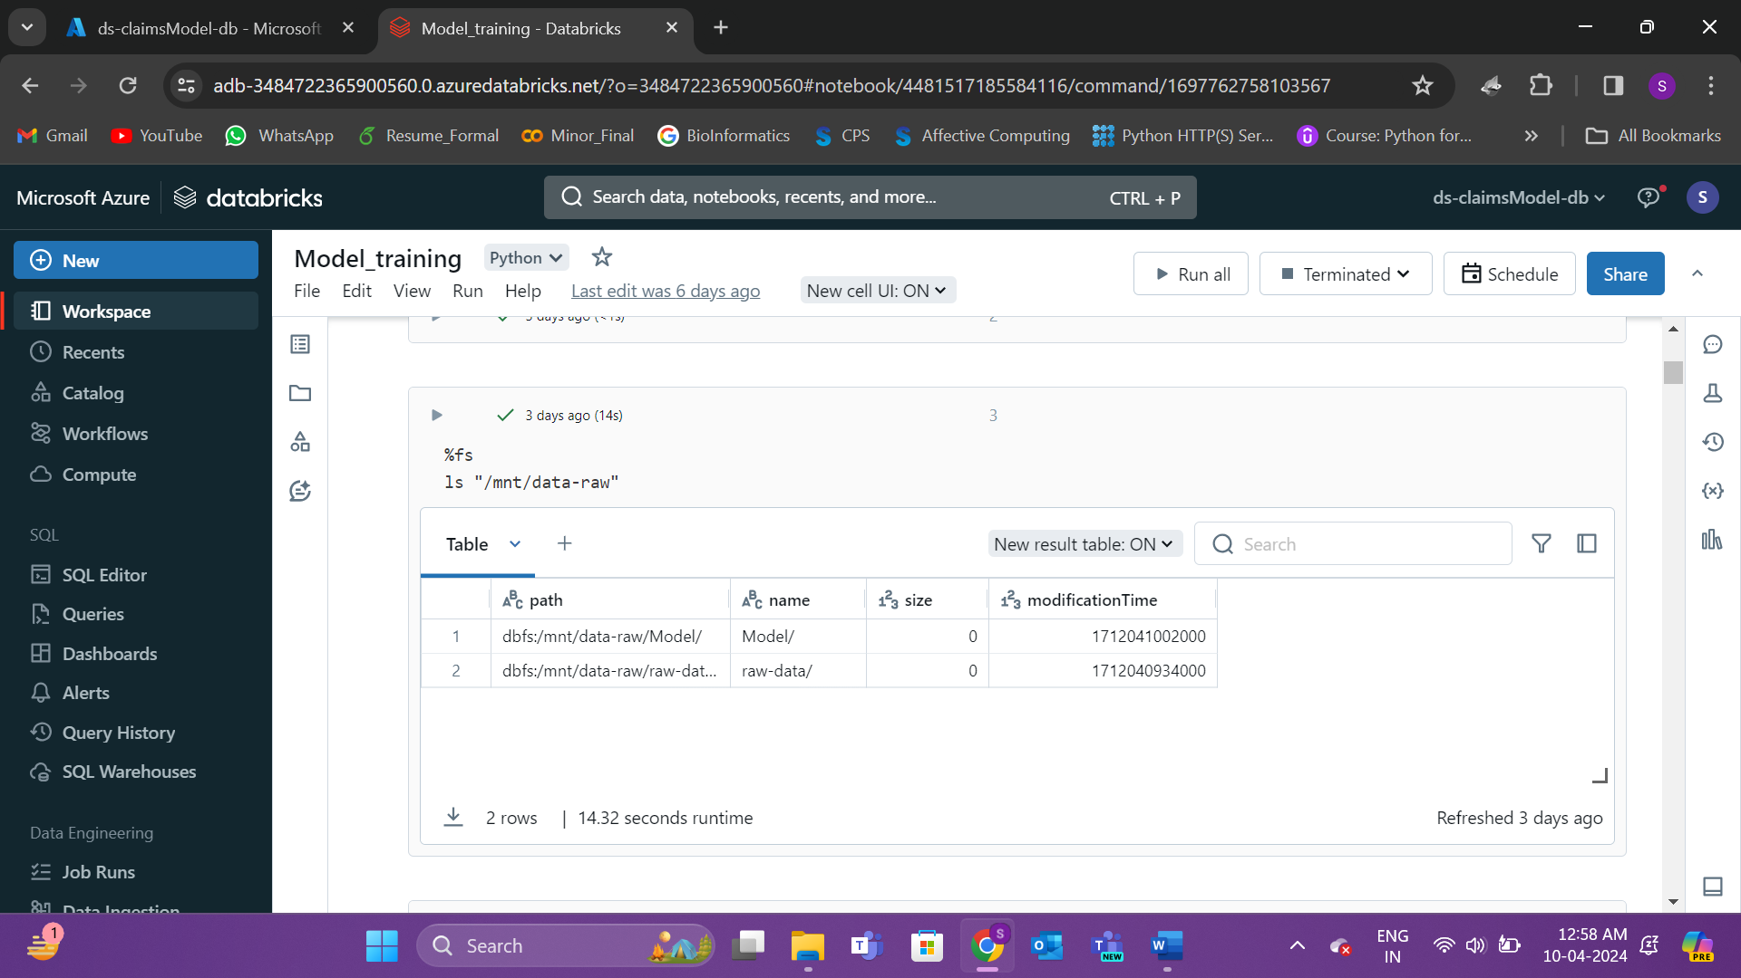

**Figure 30:** Mount point of files inside container

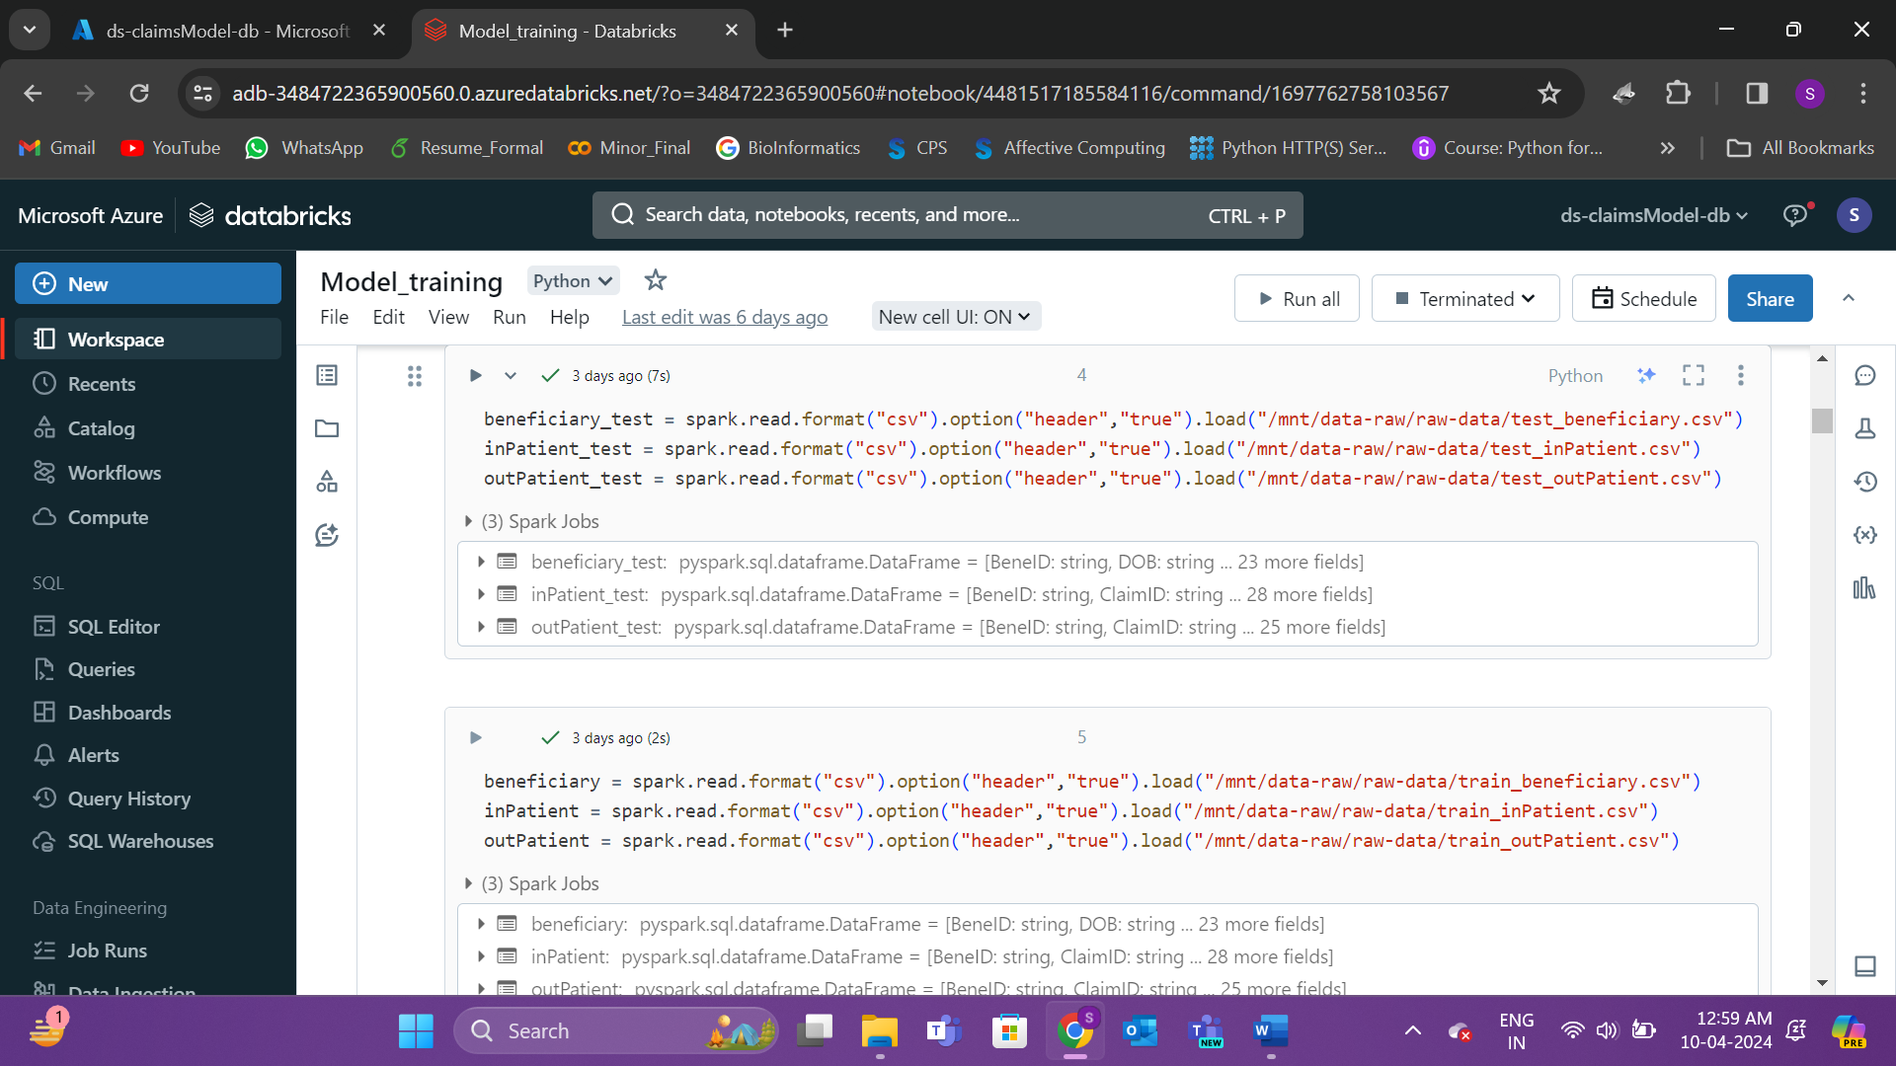

**Figure 31:** Files imported from containers

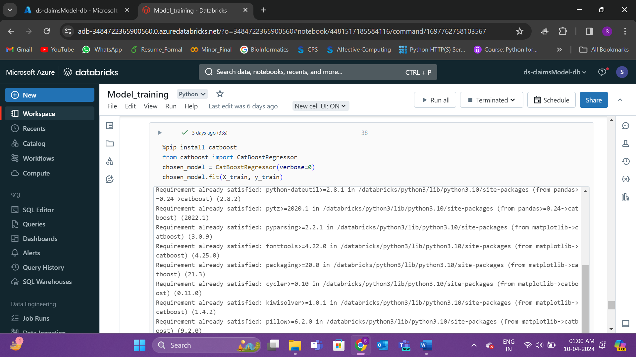

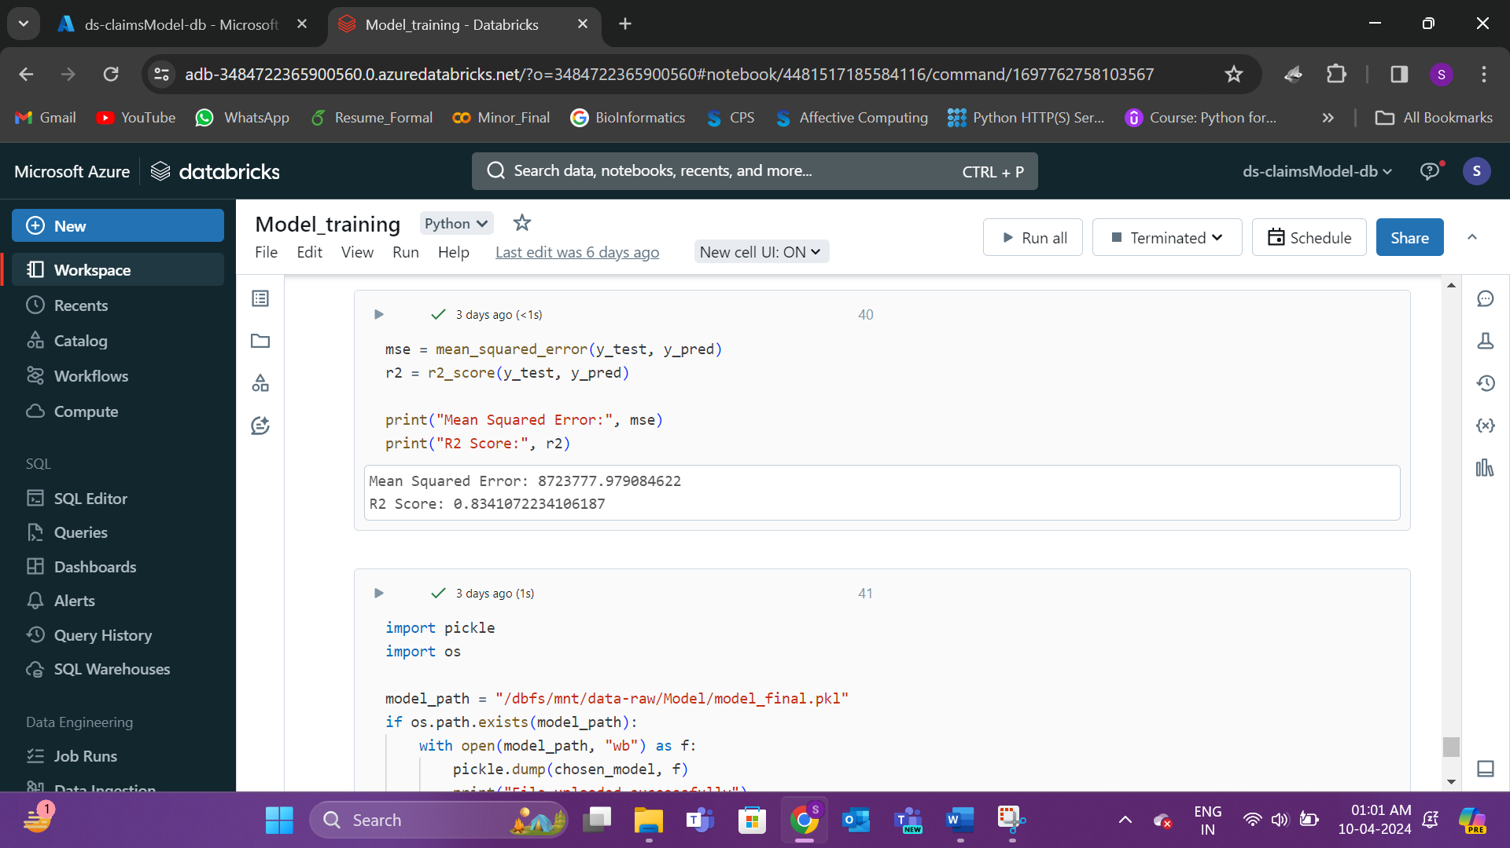

**Figure 32:** Catboost model accuracy

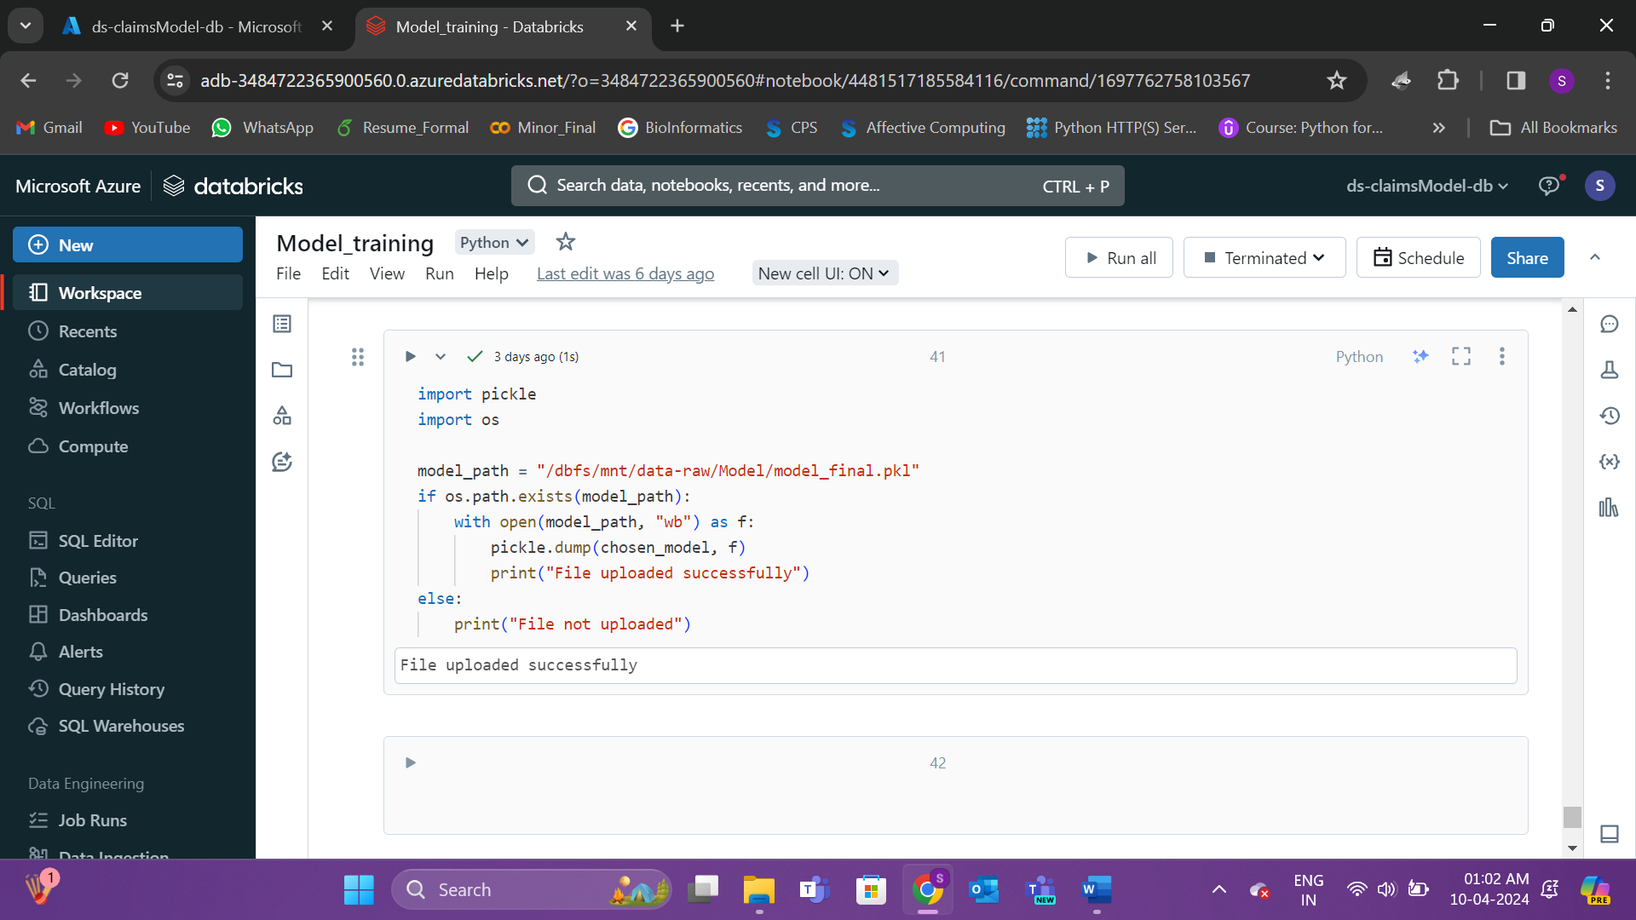

**Figure 33:** Code to mount model inside container

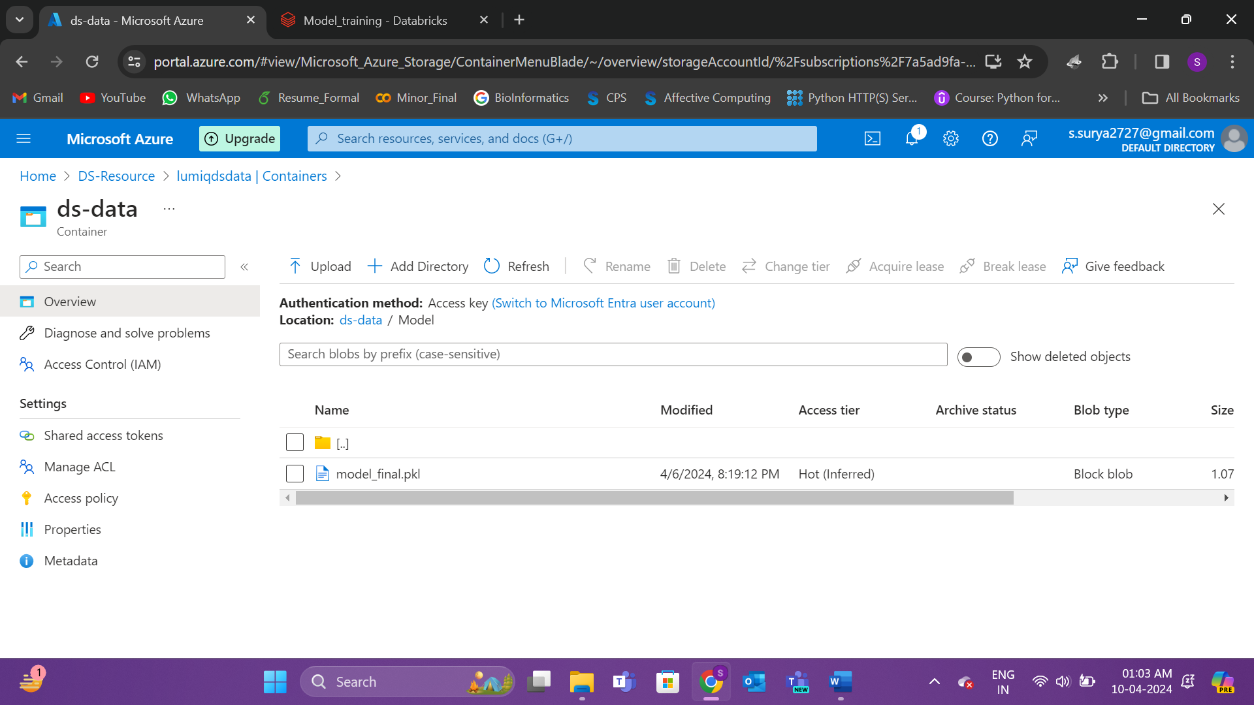

**Figure 34:** Model mounted inside container